Invitational Report: Gary Wise
Gary Wise
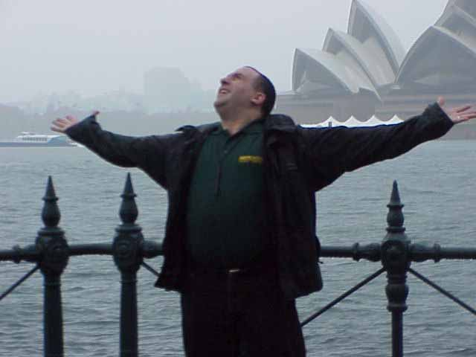
So where do I start? It's been weeks since the Invitational, and truth is that I probably should have done this by now, but between doing coverage in Buenos Aires, playing a Pro Tour and a Masters Series, finishing my Invasion draft analysis and a truckload of jetlag spread thickly over the entire 25 days I was away, I just haven't found the time or energy.
The Invitational is a truly amazing event, unlike any other on the M:tG calendar. Generally, when congregating with Jon Finkel, Ben Rubin, Zvi Mowshowitz and the like, the mood is combative. On the surface we're cordial, even friendly, but underneath we're always hiding secrets from one another. What are you playing? How do you see the format? These and other questions lurk behind every conversation, and we're all constantly aware of it.
This is where the Invitational stands out. Sure there's competition involved, but we're competing for the right to design a card, not 30 grand. Those guys I listed above, they aren't opponents. Sure, we have to play against one another, but this time we're working together to promote the game, going out for dinner, sharing stories and creating new ones. That's what makes the Invitational so great for the players. We're just a bunch of gamers hanging out with one another.
With this all said, the following are my observations about the Invitational, its participants and the great country that housed the event. To those of you expecting another 40-some page odyssey badmouthing and questioning everything, sorry, but that was an isolated event at a particular time. You're reading the wrong report. Here's then is the Wise-eye view of the Magic: the Gathering Invitational. Enjoy.

THE LOCATION
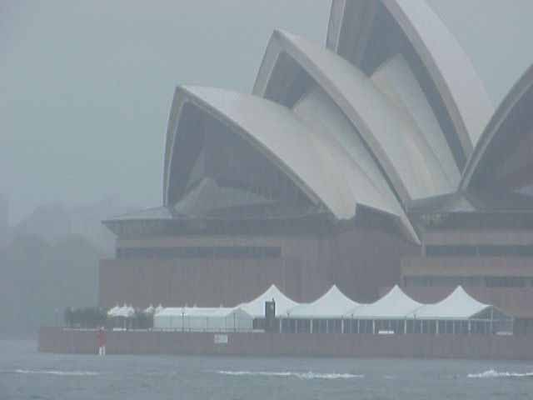
Back when I was a kid, before I understood the ways of the world (not that I've gained a full understanding of such things, but childhood breeds a certain naiveté that allows for unbounded hopes) I had a very simple plan: be rich by the time I was 25 and use my wealth to spend my time traveling, spending one year in each location for the rest of my life. The first year was supposed to be spent living in the apartments beyond Wrigley Field's bleachers, from whose rooftop I would be able to act as if I had season tickets for the Chicago Cubs from the comfort of my own home. The year after that, I was to move to Sydney.
Sydney has a sterling reputation. Her citizens are known for a laid back approach, her skyline for its beautiful architecture and neither rumor could be further from the truth. To say that the people were hospitable would be a slight. I went to Australia completely unprepared for the tourney, but Aussie pros Ben Seck and Rob Ho took care of me, not only providing the cards I needed for the tourney, but also transportation and information as it was required to see the sights and understand the sounds. Did I come back fluent in the Aussie version of English? Far from it, but at least I felt confidant that I wouldn't be mocked too roughly when asking what slang meant, a building was or what cultural icons were the real ones to investigate.
The one worry I had about the trip to Sydney was that it might be akin to arriving to a party at 7 AM only to find burnt out bodies strewn about the furniture, the party over. With the Olympics having just come to their conclusion weeks earlier, I thought that the Aussies might be sick of foreigners invading their turf. Turns out my worries were unfounded. The aforementioned laid back attitude of the populace had been applied when the world's eyes were upon them. While the Aussies appreciated the spectacle of the Olympics, they also apparently approached it with the understanding that there were more important things. When it was over, it was back to life a usual and that meant we were welcomed with open arms.
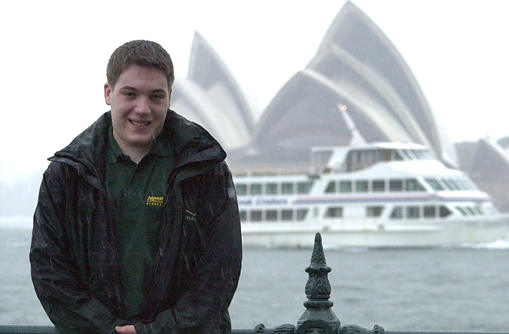
Kai Budde
Considering how long I was in Australia, I didn't do much sightseeing. Sure, I went down to the Opera House and checked out the botanical gardens with Kai Budde (with who, for the second Invitational in a row, I arrived four days early) and the aforementioned Mr. Seck, but mostly I hung out with Aussies doing the little thing Aussies do. No, that doesn't mean I wrestled Crocodiles and drink Fosters (which is only drunk in Australia by silly foreigners who think they're getting the Australia experience), but instead I went to local hangouts for hot dogs and the like. Good times.
If you're never had the pleasure and want to know what Sydney is like, I think it is best described as being Toronto with an accent. Of course, if you've never been to Toronto (Though many of you will be coming here this summer) then you have no frame of reference, but Sydney doesn't have the gritty feel of an American metropolis. The buildings are new, the streets clean and skies gray more often than not. The restaurants have an American feel and share American names, the TV a five-channel enterprise.
On my way to the airport, I turned to Rod Ho, my chauffeur for that moment in time and said, "I could definitely live here." Australia has all the conveniences that North Americans are used to with warmer temperatures (for some of us) and beaches as far as the eye can see. It's definitely a trip worth taking.

THE TOURNEY
By the time the tourney happened, I'd been in Australia for a week. Like last year, my preparation was non-existent, consisting mostly of dining, playing poker and watching Gladiator more times than I can count. As there were really only two formats I could prepare for, I received a number of advisory e-mails (thanks to everyone for their help) with decklist options, finally deciding on the Humility Prayer deck John Ormerod sent me and a mono-blue Forbiddian deck provided by Calgary's Mike Bower. I was a little nervous with last year's result on my mind, but I decided that as this would be the only non-sanctioned tournament I'd play al year, I was even going to allow take backs, as I didn't consider myself a legitimate contender.

Duplicate Sealed
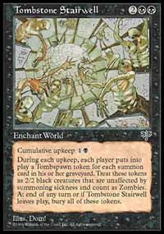
To say my track record going in to the tournament wasn't very good in Duplicate Limited is an understatement. The first format in the last Invitational, I started off that tournament by getting crushed by Jakub Slemr, Koichiro Maki and Nikolai Herzog. In other words, Duplicate Sealed was the springboard from which I vaulted to the worst record in Invitational history. This said, I was a little nervous about the possibility of a repeat performance. I looked briefly at the white and blue cards and quickly became convinced that some combination of red, black and green was the right way to go. I guess that was a good start, seeing as to how those colors were clearly the most successful at the end of the format. I ended up playing some combo-based elements, (Tombstone Stairwell, Survival, Goblin Bombardment) but not all of them, wanting a solid creature base.

Round 1) Chris Pikula
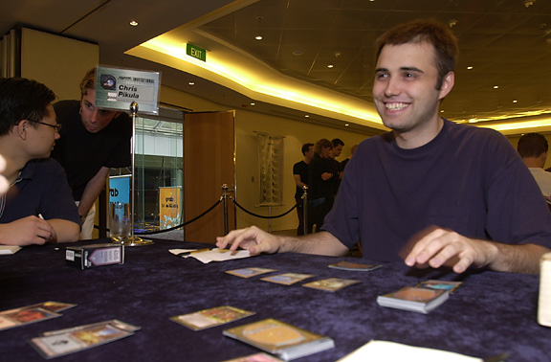
Ok, first off, let me say, there is nothing funnier than listening to Chris Pikula. Second, let me say you don't want to be his target. Chris, who has taken a step back from full time recently, is a guy I think the Pro Tour, needs, one of those few personalities who, despite an impressive resume, outshines their achievements. We sit down and start things off and ...BAM. I lose game 1. A combination of fast spells and my mana flood results in Chris beating the tar out of me. Not a good start. I'm already having visions of a 1-14 record at this point, wondering which unfortunate I would beat.
Game two started a little better. I get down a couple of fast creatures, including a Stronghold Taskmaster, and then play my combo: Khabal Ghoul and Tombstone Stairwell. After a few moments of reflection, Chris says: 'I'm pretty much screwed, aren't I' and I just smile. Suddenly though, Chris is jerked by a realization. "Wait, doesn't the Ghoul die to the Taskmaster?" He explodes with laughter, sending me on tilt with the realization of what a scrubby play I'd just made. Horrible. To make a long story short, the Ghoul dies, Chris makes a comeback, and I lose in two straight.
0-1

Round 2) Mike Long
I don't really want to get into the details concerning the conversation Mike and I had at the beginning of this encounter, but suffice to say, it was less than pleasant. The details of the match are simply that, while I made more than one mistake (I mostly made mistakes with older cards, as I find I focus very clearly on the sets at hand), forgetting for example, that Mishra's War Machine has banding, Mike's deck was built poorly (in my opinion at least), so the cards were able to carry me through. Needless to say, it felt pretty good to get an early win in, if for no other reason than to add to the belief I could do better than last year's 2-13.
1-1

Round 3) Darwin Kastle
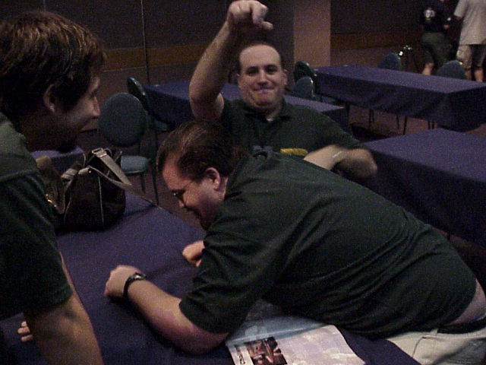
Whoever said the Invitational is friendly competition is crazy
Three rounds, three Invitational winners. Darwin and I have always gotten along pretty well, and that seemed pretty apparent throughout the match. I was able to combo Darwin out twice with the Stairwell, once with Bombardment, once with Khabal Ghoul. Darwin and I have never played outside the Invitational and money drafts, but I always find him to be a very solid, cordial opponent. I win in three.
2-1
So, having played in six format 'segments' in my Invitational 'career,' I finally had a successful one under my belt. Three rounds, two wins. Took me a lot more than that last year. Knowing now that things couldn't be that bad, I allowed myself to relax and enjoy.

Bring Your Own Block
My preparation for this format consisted mainly of mentioning in my New York report that I was going to be completely lost. A few readers took a few moments to jot down a few ideas and send them my way, but in the end I decided I liked the look of the Humility-Prayer deck John Ormerod noticed existed in the format. Unfortunately for me, that deck, unless it chose to run COP: Red main, had no chance of winning game 1 against mono red, which everyone else seemed to have settled on. Pikula, Price, Boeken, Fuller, Shvartsman... the reports kept coming in that more and more were settling on Mountains and without a back up, there wasn't much I could do about it except beef up my sideboard with many a COP and Chill. In addition, I had told Dave Price my deck configuration was set before he told me he was red, so when I found out that everyone else in the free world was running some kind of red deck, I decided to add the Chills with the provision that if I were to play Dave, I wouldn't board them in.

Round 4) Yoshikazu Ishii
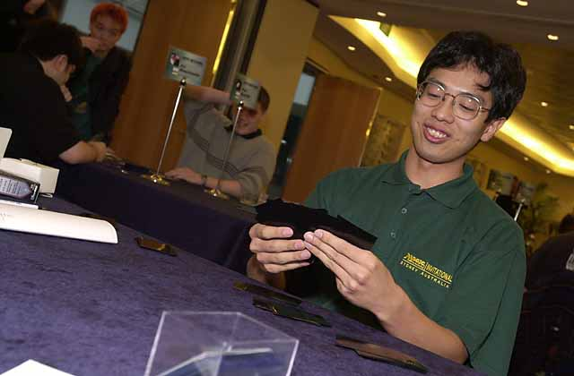
So I'm 2-1, I like my deck and I'm set up with what's supposed to be one of my easy matches. Oh man was I wrong. Ishii broke the format with a RG Rofellos deck with Plow Under (for my Outposts, no doubt), Kavu Chameleon (for my counters), Keldon Necropolis (to break my lock), Urza's Rage (for my counters), Masticore (for my chump blockers) and Obliterate (for everything else). Not only that, he also threw in a few Reverent Silences after boarding just to dominate me even more. I took a few beatings over the weekend, but this was the harshest, bloodiest and most complete.
2-2

Round 5) Alex Shvartsman
So, on the tail of that harsh beating, it's my turn to line up for defeat at the hands of Alex, who at this point was the surprise of the tournament at 4-0. With his playing two lands by turn two, I might as well have conceded and moved to game two, with his weenies and burn making a win nearly impossible.
Game two was an interesting one. I got down a COP and two Chills, completely locking the table up. Any time Alex drew his sideboarded Steel Golems, I had the Disenchants ready and waiting. Unfortunately though, every time I drew my Outpost, there was a Wasteland ready. Finally, thanks to massive card advantage from Whispers of the Muse, I was able to outrace his Wasteland draws, but with three Outposts already gone, I was only able to produce one token a turn. Finally, with my deck running thin, I made an all out assault, but it wasn't enough to get through Alex's conjured minions. I lost the unloseable game to decking.
2-3

Round 6) Bob Maher
So now, having lost the automatic and the inconceivable, I have to play the one guy who, coming into the format, I didn't want to play. Bob was the other player who chose to play Humility-Prayer, and his deck was configured a lot better than mine for the mirror match. We played two long, drawn out games with counter wars, opposing Orim's Prayers and dude on dude combat aplenty, but in the end Bob played well, and that meant that winning just wasn't in the cards, literally or figuratively.
2-4
So, having gotten crushed three straight, the fears started coming back. 2-13. Dear Lord, setting the standard for futility is one thing, but duplicating it? That'd be pretty hard to live down.

Solomon Draft
Possessing of a lifetime 0-3 Solomon record in tournament play thanks to last year's tourney, I think I'm getting better at the format, but I still have a long way to go. While yes, Solomon is a Limited format, most of my strength in Limited comes more from extensive preparation rather than particular skill. I really enjoy drafting and always have, dating back to before Magic was around and I was constantly doing baseball or hockey pools. That a baseball pool would be won on draft day was always apparent to me, so I really enjoyed attacking the problem of how to best exploit that. Now with answering that problem leading to success on the PT, I spend a lot of time learning Draft formats and the like. It's the time I invest that makes my Limited game better than its Constructed counterpart.

Round 7) Zvi Mowshowitz
Going back to the above point, this match was over when the cards were all divided. During the draft, I could sense that Zvi had basically given up on trying to make for a solid color orientation, and the cards in this all-gold draft helped disguise that I was in fact concentrating on red, blue and black. I figured there would be a lot of Invasion in the card set, meaning that those three colors might have an advantage.
When the draft was over, I was able to confine my mana to those three colors, with a couple more cards in the sideboard. I was pretty sure that I had a big advantage going into the match. Game 1 proved this to be the case. I started with a 2nd turn Hibernation Sliver and 3rd turn Shauku's Minion and never really slowed down. Zvi was able to muster a bit of a defense, but Barrin's Spite and Reckless Assault took care of that. The game took about three minutes.
Game two was different. Again, my mana curve kicked in, but Zvi was able to slow me down with tougher defensive creatures and a strong mana draw for his five color deck. Finally, he was down to just one creature, a Voracious Cobra, but he played Armadillo Cloak on it and started smashing my face in. I sat with the Spite in hand waiting for him to play another target, but it never came. Twenty life and a number of chump blockers later, we were on to game three.
This one was a lot like game 1, with a 2nd turn Sliver, third turn Urborg Drake, fourth turn 4cc creature. Zvi played three basic lands that didn't line up, and by the time he'd drawn his mana, it was too late.
3-4

Round 8) Trevor Blackwell
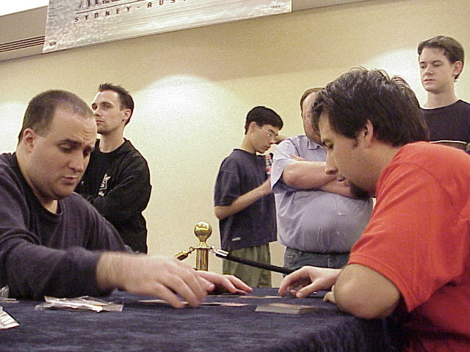
This draft seemed pretty close to me. Again, I tried to keep my color count low, staying mostly with red and black, while Trevor stayed more to a best card strategy. As a result, he got some of the environment-defining powerhouses like Empress Galina and Sisay, but we both agreed that the match up was a close one going into the actual playing.
Game 1 was a long, drawn out affair that was dominated by Ertai. I was finally able to break through with Keldon Necropolis, but, by that time, I'd drawn every blue card in my deck without a blue mana source, and when he cast Empress Galina, it was all but over. Tough way to learn that she can control legendary non-creature permanents.
Game two was mine thanks to mana problems on Trevor's side of the table. This isn't too shocking in the five color environments (Trevor was playing four), but it was still lucky on my part. Game three was about my drawing power cards and getting Tsabo Tavoc into play. Let me tell you, when everything says 'Legend' on it, she's great, even though you just use her to attack for seven. What a beast.
4-4

Round 9) Ryan Fuller
Ryan and I have something of a history and it isn't a harmonious one. That said, neither of us are introverts, so when the pairing was announced, we both made a little noise. To say I was happy with the way the draft went would be a lie. I tried basing my deck around white hosers (this was the all hoser draft) but the packs were less than cooperative. I ended up ditching white altogether, running a BRU deck. The one part of the draft that did go well was Ryan's passing me both Whim of Volrath and Blind Seer. While I knew both were good, I didn't fully realize how strong they were here until the match.
Game 1 saw me play a 3rd turn Krovikan Sorcerer. Once the 1/1 became active, I started using it for huge card advantage, more than willingly discarding black cards to draw 2. This allowed me to set up a defense with King Crab as a large body who, after I'd stabilized, combined with Whim of Volrath to get Ryan in a hard lock, returning any creature he had to his library. Even Volrath's Laboratory (producing Fuller tokens) wasn't able to stop the combo.
Game two was similar. This time it was Whim of Blind Seer and King Crab that combined for the lock. Simple fact is, you remove your opponent's draw step and their chances of winning aren't too good.
5-4
I'd actually 3-0ed a format! The sky fell, hell froze over and you don't want to know where those monkeys came from. Not only that, but I was above the 50-50 mark with only six rounds to go. Speculation on anything more seemed ludicrous, so let's just leave it that way.

Auction of Champions
Now this was the one I was looking forward to. Not only were there questions lingering as to how far down the assorted decks would go, but also I was really curious to see how the competitors valued certain decks. Many of the baseball pools I mentioned earlier were based on an auction system where, like in this format, we (the owners) only had so many resources to allocate in recruiting our teams. A lot of the time, those auctions were won by those who resisted the urge to overspend on superstars and wait for the good deals that would invariably come at the end of the auction.
At the beginning of the auction, the deck I wanted most was the Dolan deck. Not only did it contain cards that could beat every deck, but it also looked like a lot of fun to play, especially my favorite card of all time, Chaos Orb. I also wanted to try to drive up the bid totals on the decks preferred by my remaining six opponents: Price, Boeken, Finkel, Godinez, Rubin and Budde. I figured the big decks, specifically Hovi and Buehler, would go for too much, so I had no plans to go for either. Then I got outmaneuvered.
When it came time to bid on the Buehler deck, 4-5 players had already been removed. I was ready to take the deck to 6 cards immediately, as the Necro-Ritual-Consult nucleus could more than make up for it. When the deck came to me a second time, the bid was reasonable, so I stayed in. When it came to me a third time, it was at 6 cards, 14 life. I decided that, with 6-7 competitors still in the bidding, I'd move it to 6/13. Unfortunately, it seems that's where everyone reached their limit. One after another, players sat, until it was down to me, Pikula and Finkel. Chris stood there thinking as I prayed inwardly that he would go lower, but finally he decided the cost was too high and passed, as did Jon. Not only did I get a deck I didn't really want, but I also got it at the wrong price. I think that with the nature of the Buehler deck being what it is, I would prefer to have started with 5 cards, 20 life. Instead, I was forced to start at 13 life, leaving me short on expendable life-based resources, which would be critical.

Round 10) Jon Finkel
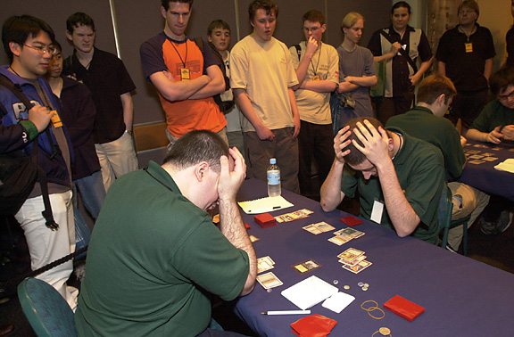
Bad times?
So I miss out on the deck I wanted, the best player in the history of the game gets it, and I have to play him first round. Jon had to do a couple of interviews prior to the match, so I pulled a player out of the stands and played a few games against "Finkel" (at least that's what the sign said) for the assembled onlookers. Let me tell you, the Buehler deck isn't great against 21. I had a lot of fun though and got a chance to play a few games as a preparation measure. Too bad it didn't help.
Every spell I cast against Jon, he had the answer. I'd play Ishan, he'd have Meekstone, I'd play Order of the Ebon Hand, he'd have Siren's Call in tandem with Kismet. I'd play Necro, he'd have Armageddon. It was ugly, and Jon got me into a soft Stasis lock long enough to gain the upper hand and win the match.
5-5

Round 11) Kai Budde
Not only do I have an overcosted deck, but I also get one of my worst match ups in the form of the Budde deck, being played by the man himself. Cursed Scroll, Wildfire, Temporal Aperture, the deck was full of anti-Necro bombs that made the winning next to impossible. In both games I lost, my mana draws were horrid, and I was forced to mulligan to four in one of them, but let's be honest: I wasn't winning this one.
5-6

Round 12) Dave Price
One problem with playing the classic Necro deck is the possibility of a bad Consult. My draw game 1 was awesome, with every ingredient present. Unfortunately, I cast a Consult that left me something like 6 cards and 2 damage sources, and those two couldn't do enough to reduce Dave to 0. Totally frustrated with the format by now, I conceded rather than wait for Dave to kill me.
Game two was all about one card: Lobotomy. Dave got my Drain Lifes and with it any hope of my being able to get the Necro engine running well. This ruined another great draw, leaving me feeling like a beached fish, flapping my fins without any results. Dave won in two straight, leaving me 0-3 for the format.
5-7
Told you there was no point in considering my being in contention.

Type 1
Back in the day, when I was starting out in the game, I was a Type 1 player. There was no draft, there was no Standard, there was no Block Constructed, there was only one format. You used a maximum of four of each card, with some restricted to one, but you could use any card ever made, save the Ante cards and a few silly cards like Channel. This lasted until the weekend of the Mirage pre-release, where my Type 1 deck was stolen. With my beautiful Alphas and Beta's gone and a student's bank account at my disposal, I was forced to discover Sealed Deck, and Magic completely changed for me. Nine months later when I caught the thief thanks to some highly identifiable cards (let me tell you, you have to be pretty stupid to play a stolen Beta Lotus with 35 gold signatures on it), I'd lost all interest in playing Type 1, meaning now, four years later, I'm completely uninformed.
My preparation again was limited to e-mails received in response to my plea for help, and I was totally ready to play the mono-blue Forbidian deck a friend from Calgary, Mike Bower, recommended to me. Now though, I knew who I'd be playing: Godinez, Rubin and Boeken, and I sensed a lot of Mountains and quick creatures would be coming out of their decks, so I decided to infuse my deck with some black (mind Twist, Tutor, Will, 2 x Abyss) while replacing the Ophidians, ironically, with Masticore.

Round 13) Gerardo Godinez.
Now this guy I KNEW would be playing Sligh. He'd played it against me at Worlds '99, he'd played it in BYOB, I was pretty sure I'd be looking at first turn Pup and the like. Game 1 played out exactly as I wanted. Counter some stuff on turns one and two, play the Abyss on turn three, console my opponent. It was an absolute beating, but Gerardo took it well. Obviously, this match up wasn't a good one for him, so he engaged in trash talking and the like and had a good time with the whole thing.
Game two should have been over quickly. Not only did I get down the early Abyss and a Masticore to go with it, I also got out Ivory Tower and Zuran Orb. Fortunately for Gerardo, he was able to draw into one of his boarded Shattering Pulses and started using it with buyback. I finally countered it on its second use, fighting my way through his Pyroblast, but the indirect result of this was the lowering of my hand size. Around this time, Jeff Donais came over and sat down next to Gerardo to get a better view. The kept on going, but he was making a comeback. I dealt with his second Pulse, but then he drew a third, and he always seemed to have the needed Pyroblast. Despite my having gained a lot of card advantage (or so I thought) Gerardo pulled things to even. This all seemed really suspicious. Not knowing Gerardo too well, I pulled Jeff aside to mention that it seemed like I had 10-15 cards of advantage thanks to Masticore, Stroke, Twist, FoF and the like, and was it even conceivable that Gerardo was drawing extra cards and the like, but Jeff assured me that this wasn't the case and we went back to the match. Two turns later, however, I figured out what was going on. Gerardo cast his fourth Pulse at which point I grabbed his graveyard only to find one Pulse in it, at which point he and Jeff burst out laughing. The joke was on me. It seems that the respectable Mr. Donais had been passing him cards in the best interest of Hasbro Mexico, but to no avail. With the two compadres busted, Godinez extended the hand.
6-7

Round 14) Noah Boeken
Well, I won this one 2-1, with game 1 ending on the first turn with Noah's Ancestral being Misdirected to me. I got to the point where I was drawing so many cards that I was forced to discard, but it didn't matter because I was Mind Twisting, Fact or Fictioning and Stroke of Geniusing like a madman. Eventually Masticore finished him off. Game two wasn't so good. Noah got down a Scepter and seemed to draw more counters than I did spells. Game three, a little draw, a little discard and I was on my way.
7-7

Round 15) Ben Rubin
Well, I was out but Ben wasn't. Needing a win and a Dave Price loss, Ben came to the table with a lot on the line. Despite the fact that Ben and I friends, I assured him I had to play to win, and he expected nothing less. Game one was all about 1st turn land, Lotus, Abyss. After that, there really wasn't much Ben could do. Same kind of thing happened in game two, which included a turn in which I Stroked and Twisted after casting Yawgmoth's Will. Pretty savage. I don't know how fair a format T1 is, but sometimes it's a lot of fun.
8-7

FINAL THOUGHTS
Well, I broke out of my Invitational mold with an above .500 (and therefore respectable) finish. Here are a few things I brought away from the experience:
• I'm good with kids. Seems that Rachel Rosewater, Mark's offspring, took a liking to me. By then end of the trip, when the Rosewaters needed a break, they'd call on me to take her. It must be noted that this was not a selfless act on my part: Rachel was a lot of fun
• Chris Pikula does amazing things to conversations. Saturday night, Chris, Worth Wollpert, Bob Maher, Skaff Elias, Ben Rubin and I went to dinner, where the conversation ranged from how many Shirley Temples one man could drink to things one can do when bored on airplanes. This definition doesn't accurately sum up the conversation, but trust me, it'll have to do.
• Skaff Elias, Randy Buhler, Worth Wollpert, Mark Rosewater et al love Magic. It's very apparent to anyone at the Invitational that the whole thing takes a lot of work that may not need doing, but these guys do it for their love of the game. Thanks guys.
• Kangaroo and Crocodile taste pretty good. The former is a tangy steak, the latter a bland chicken.
• Ryan Fuller and I can co-exist. Maybe things aren't hopeless in the middle East after all
• The Japanese and Latin American Invitational spots are warranted. Not only did both representatives do well, but Ishii in particular injected a lot of creativity into the constructed formats.
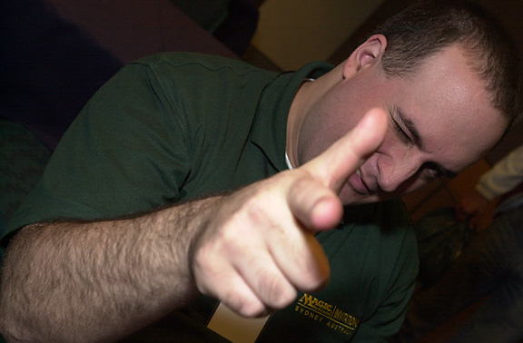
• Jon Finkel is incredible. I know, it's been said, doesn't mean I can't re-iterate. People have said in the past that there are those who are as good as Jon but not as lucky. They're wrong, no question.
• Australians are good times. Mike Doake, Dane and Liam Coltman, Rod Ho, Ben Seck et. al. are great people who love to game. Thanks for the good times.
• That's about it. Sorry there aren't another 30-some-odd pages tacked on here. Thanks for reading, hope you enjoyed.

